Microsoft Azure - Starter Kits for Partners

Architecture

Enterprise Mobility Suite

Last Update: September 2015





MICROSOFT MAKES NO WARRANTIES, EXPRESS, IMPLIED OR STATUTORY, AS TO THE INFORMATION IN THIS DOCUMENT.

The information contained in this document represents the current view of Microsoft Corporation on the issues discussed as of the date of publication. Because Microsoft must respond to changing market conditions, it should not be interpreted to be a commitment on the part of Microsoft, and Microsoft cannot guarantee the accuracy of any information presented after the date of publication.

Complying with all applicable copyright laws is the responsibility of the user. Without limiting the rights under copyright, no part of this document may be reproduced, stored in or introduced into a retrieval system, or transmitted in any form or by any means (electronic, mechanical, photocopying, recording, or otherwise), or for any purpose, without the express written permission of Microsoft Corporation.

Microsoft may have patents, patent applications, trademarks, copyrights, or other intellectual property rights covering subject matter in this document. Except as expressly provided in any written license agreement from Microsoft, the furnishing of this document does not give you any license to these patents, trademarks, copyrights, or other intellectual property.

The descriptions of other companies’ products in this document, if any, are provided only as a convenience to you. Any such references should not be considered an endorsement or support by Microsoft. Microsoft cannot guarantee their accuracy, and the products may change over time. Also, the descriptions are intended as brief highlights to aid understanding, rather than as thorough coverage. For authoritative descriptions of these products, please consult their respective manufacturers.

© 2015 Microsoft Corporation. All rights reserved. Any use or distribution of these materials without express authorization of Microsoft Corp. is strictly prohibited.

Microsoft and Windows are either registered trademarks of Microsoft Corporation in the United States and/or other countries.

The names of actual companies and products mentioned herein may be the trademarks of their respective owners.

Contents

Overview 4

Cloud-Only vs. Hybrid Deployment 4

Solution Architectures 4

Azure Active Directory Premium 4

Azure Active Directory Connect (AAD Connect) 5

Directory Synchronization vs. Federated Identity 5

Azure Rights Management Service 5

Cloud-Ready 5

Cloud Accepting 5

Cloud Reluctant 5

Microsoft Intune 5

Cloud-only deployment 5

Hybrid Deployment 6

Architecture for Applications Servers on Azure

# Overview

The purpose of this document is to provide deployment options of the 3 core solutions available in the Enterprise Mobility Suite: Azure Active Directory, Azure Rights Management Services, and Microsoft Intune.

# Cloud-Only vs. Hybrid Deployment

Each of the core solutions in the Enterprise Mobility Suite can be configured for either a standalone “cloud-only” deployment or a hybrid deployment that includes some mechanism to connect to on-premises infrastructure. The choice to integrate cloud solutions with on-premises infrastructure needs to take several factors into consideration and should be carefully considered during deployment planning for each of the suite’s solutions.

# Solution Architectures

## Azure Active Directory Premium

Many customers already leverage Azure Active Directory when they use Microsoft online services like Office 365. Users and groups created in directories associated with solutions like Office 365 will be available to for configuring SaaS application access management using Azure Active Directory Premium. However, customers often integrate their cloud directory with on-premises directories to provide hybrid identity capabilities.

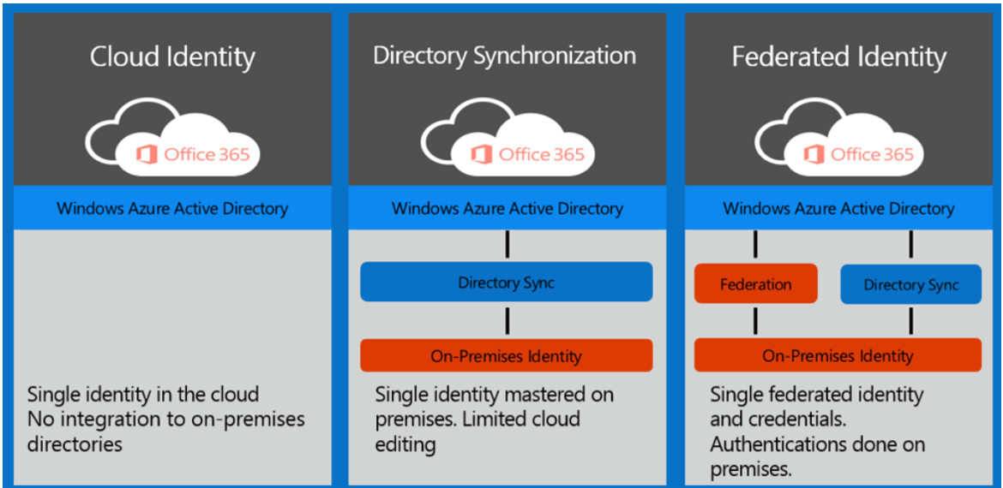

There are different design and configuration options for hybrid identity using Microsoft solutions, and in some case it might be difficult to determine which combination will best meet the needs of your organization. Use the Hybrid Identity Design Considerations Guide to help design a hybrid identity solution that best fits the business and technology needs of the organization: <https://gallery.technet.microsoft.com/Azure-Hybrid-Identity-b06c8288>.

### Azure Active Directory Connect (AAD Connect)

Azure AD Connect is the tool to integrate an on-premises identity system such as Windows Server Active Directory with Azure Active Directory.

<https://azure.microsoft.com/en-us/documentation/articles/active-directory-aadconnect/>

### Directory Synchronization vs. Federated Identity

See item “4 - Azure AD – Deployment Options.pptx” of the Azure Starter Kit – Enterprise Mobility.

## Azure Rights Management Service

Deployments of Azure Rights Management Services are integrated with Azure Active Directory as well as Office 365. In addition to these cloud capabilities, on-premises deployments of Office and file server workloads can be integrated with Azure RMS.

### Cloud-Only

In this case, the customer uses Azure Rights Management Services directly through integration of their on-premises Active Directory to Azure Active Directory. Authentication and authorization of rights-protected materials in Office 365 is performed by Azure RMS leveraging Azure AD user and group identities.

### Hybrid

In this case, the customer may still have on-premises deployments that use Microsoft Exchange Server, Microsoft SharePoint Server, or file servers that run Windows Server and use the File Classification Infrastructure (FCI) capability of File Server Resource Manager. The Azure RMS Connector enables on-premises servers to use their Information Rights Management (IRM) functionality with Azure Rights Management Service (RMS).

*See item “4 - Azure RMS – Deployment Options.pptx” of the Azure Starter Kit – Enterprise Mobility.*

## Microsoft Intune

### Cloud-only deployment

A cloud-only deployment of Microsoft Intune does not require the presence of on-premises infrastructure like System Center Configuration Manager. It benefits from an increase cadence of functionality and feature releases, but cannot provide full PC and cross-platform management capabilities as when integrated with on-premises infrastructure.

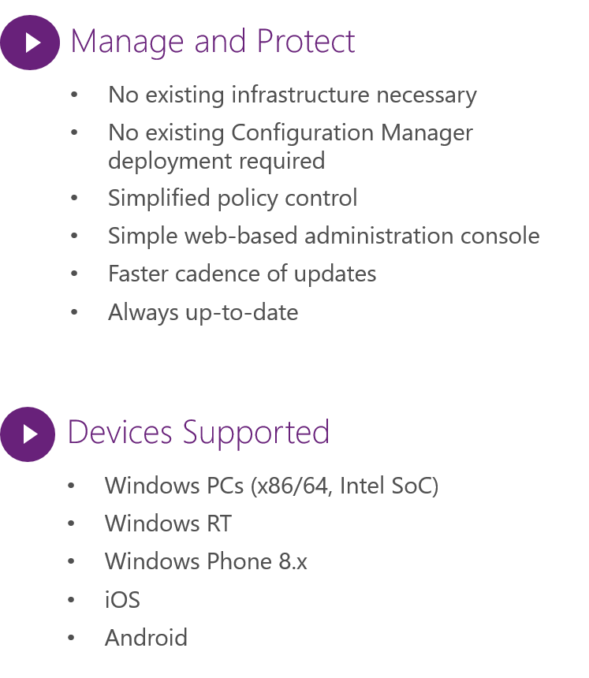

### Hybrid Deployment

In a hybrid deployment, a Microsoft Intune subscription is integrated with System Center Configuration Manager. This allows for broader device and platform support as well as traditional configuration management tasks like application and operating system deployment. However, a hybrid deployment will not have the same “cloud cadence” of updates and new functionality releases that are available in a cloud-only deployment.

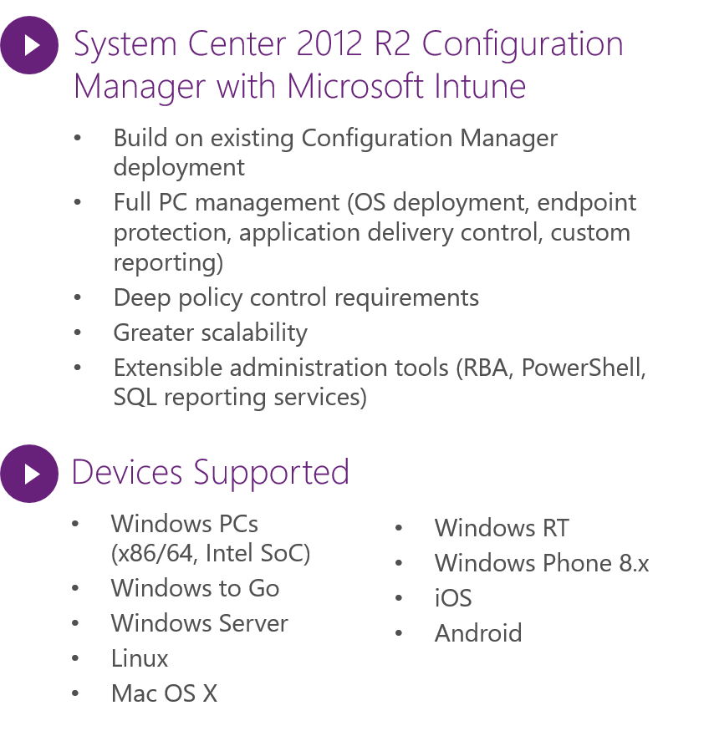

*See item “4 - Microsoft Intune – Deployment Options.pptx” of the Azure Starter Kit – Enterprise Mobility.*